通过Android AIDL跨进程获取

服务端包名，类名和aidl名
private static final String AOLEYUNDESKTOP_PACKAGE_NAME = "com.aoleyun.sn";
private static final String AOLEYUNDESKTOP_CLASS_NAME = "com.aoleyun.sn.service.RemoteService";
private static final String AOLEYUNDESKTOP_ACTION = "com.aoleyun.sn.SystemInfoInterface";

需要用到的变量
private SystemInfoInterface mSystemInfoInterface;
private ServiceConnection mServiceConnection;

初始化ServiceConnection

this.mServiceConnection = new ServiceConnection() {
@Override
public void onServiceConnected(ComponentName name, IBinder service) {
Log.e(TAG, "onServiceConnected: " + name);
mSystemInfoInterface = SystemInfoInterface.Stub.asInterface(service);
try {
for (ConnectedListener listener : mListeners) {
listener.onRemoteConnected();
}
String sn = mSystemInfoInterface.getSerial();
initPush(sn);
Log.e(TAG, "onServiceConnected: sn: " + sn);
if (!TextUtils.isEmpty(sn)) {
mMMKV.encode(SERIAL_KEY, sn);
}
} catch (RemoteException e) {
e.printStackTrace();
Log.e(TAG, "onServiceConnected: " + e.getMessage());
}
}
@Override
public void onServiceDisconnected(ComponentName name) {
Log.e(TAG, "onServiceDisconnected: " + name);
mSystemInfoInterface = null;
bindinfoService();
}
};

连接aidl
private void bindinfoService() {
//这是连接aidl服务的代码
Intent intent = new Intent();
intent.setAction(AOLEYUNDESKTOP_ACTION);
intent.setPackage(AOLEYUNDESKTOP_PACKAGE_NAME);
intent.setComponent(new ComponentName(AOLEYUNDESKTOP_PACKAGE_NAME, AOLEYUNDESKTOP_CLASS_NAME));
mContext.bindService(intent, mServiceConnection, Context.BIND_AUTO_CREATE);
}

获取SN
String serial = mSystemInfoInterface.getSerial();

在项目app上新建aidl文件夹

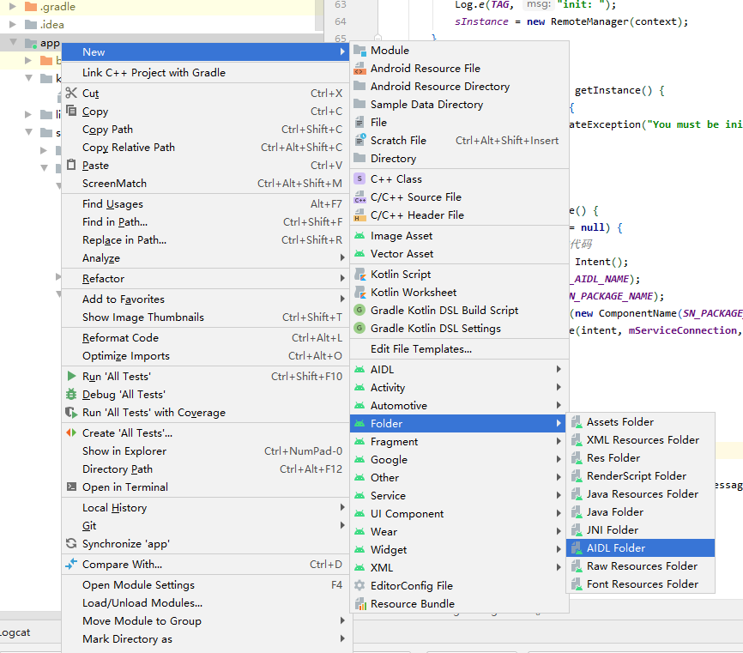

新建文件夹要和包名匹配

